Hands on Assignment 3

Shreya Rai
University of the Cumberlands
Course Number: MSCS-633-M50
Dr Ulrich Vouama
07/05/2026

Hands on Assignment 3
GitHub link - https://github.com/ShreyaRai20/HandsOnAssignment3Chatbot.git
Training chat:
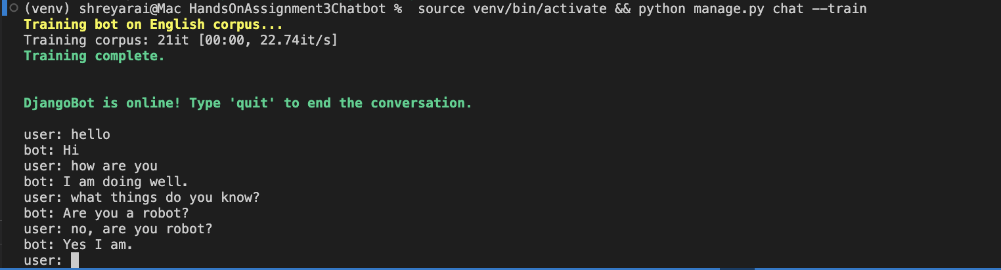
Training chat and conversation chat
